Assingment-1

|  |  |
| --- | --- |
| Name | Harinath V |
| Register number | 723619106005 |
| Team ID | PNT2022TMID43975 |

Question:

Using PIR sensor and tmp36(Temperature sensor), piezo alarm, Create a circuit with Arduino uno with below functionalities.

1. Alarm should give one sound when there is a motion near PIR sensor.

2. Alarm should sound with different sound when the temperature is above 60 degrees .

Software used:

Tinkercad

Circuit Design:

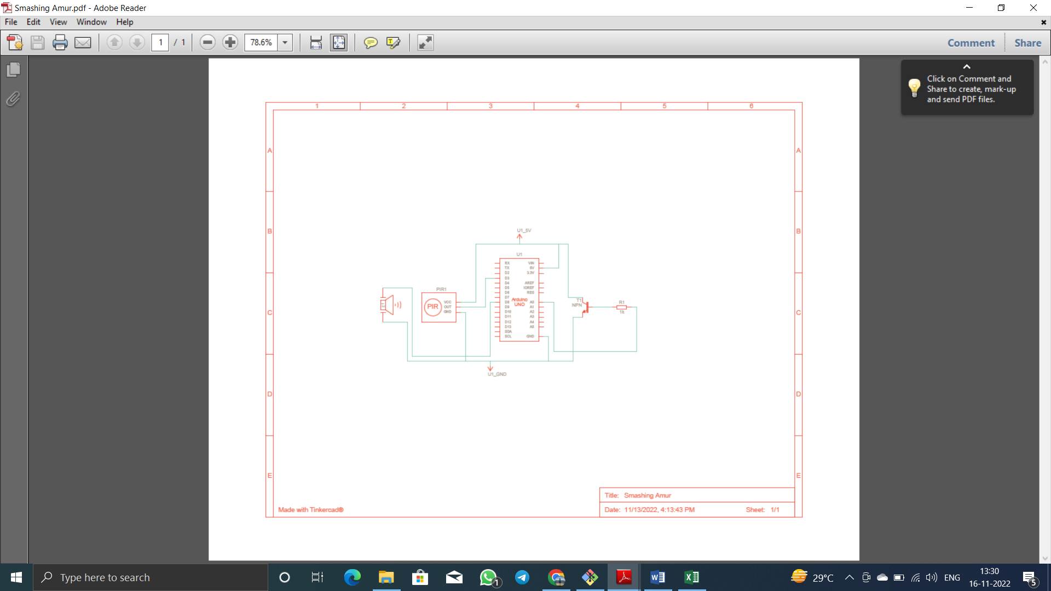

Circuit:

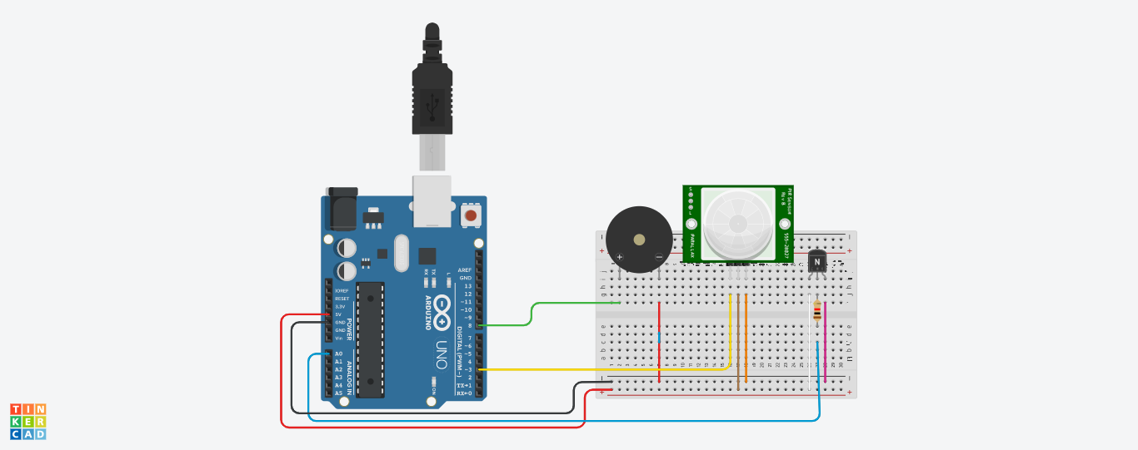

Adriano Code:

#define temp A0

#define pir 3

#define buzzer 8

int motion =0;

double t;

void setup()

{

pinMode(buzzer, OUTPUT);

pinMode(temp, INPUT);

pinMode(pir, INPUT);

Serial.begin(9600);

}

void loop()

{

motion = digitalRead(pir);

int reading = analogRead(temp);

t = (double)reading / 1024;

t = t * 5;

t = t-0.5;

t = t * 100;

Serial.println("motion not detected");

Serial.println("Temperature: ");

Serial.println(t);

if (motion == 1)

{

Serial.println("Motion Detected!!!");

digitalWrite(buzzer,HIGH);

delay(1000);

digitalWrite(buzzer,LOW);

delay(10);

}

else if(t > 60)

{

Serial.println("High Temperature Detected!!!");

for(int i=0;i<3;i++)

{

digitalWrite(buzzer,HIGH);

delay(1500);

digitalWrite(buzzer,LOW);

delay(500);

i++;

}

}

delay(1000);

}